**BACKGROUND/ MOTIVATION:**

As vaccine production & procurement processes are speeding up, proper & fair sharing of it is a thing to concern. As large amount vaccine units roll out, the first step is strategic & wise distribution of it among various regions, considering conducive & causative factors raising urgency of requirements. For this, organizations & government may look upon the predictive suggestions backed by data & taking its help, chart out the further plans.

**PREFACE/ INTRODUCTION:**

Many countries, particularly those in the developing world, where governments have struggled to procure vaccines, are not yet vaccinating residents at all. One of the decision to be taken strategetically is wise & calculated distribution of vaccine received.  
  
Our algorithm helps to estimate the appropriate amount of vaccine units needed, & moreover suggests the % division amongst countries or regions based on data & parameters like population count, prevalence of co-morbid diseases and age related statistics. As unanimously suggested by all the healthcare experts & researchers, the senior citizens are highly prone to getting affected due to less immunity levels, it might be difficult to recover too. Apart from that, the people already affected with diseases like HIV & other diseases, show symptoms of low immune levels too which require more attention & concern. Thus, these kind of additional factors, along with alarming new covid cases & less recoveries or more susceptible populations, require quicker attention & contribute & indicate to urgency factor of vaccine dosages required for such population.  
  
Thus, considering all these metrics & the hidden parameters which indirectly affect the vaccine unit requirement of the region, we have able to come up with a model that predicts & categorizes urgency levels & % requirements of vaccine units, on basis of population, age, comorbidity datas affecting covid susceptibilities & stats of active & new coming cases.

**APPROACH/ METHODOLOGIES:**

To make an accurate prediction for the spread and vulnerability of Covid19 in the population the prediction engine relies on Unsupervised Machine Learning Techniques.

Prediction Engine Consists of two levels of clustering algorithm(K-Mean Algorithm) followed by a supportive Deep-Net- algorithm

**Diagram:1.1**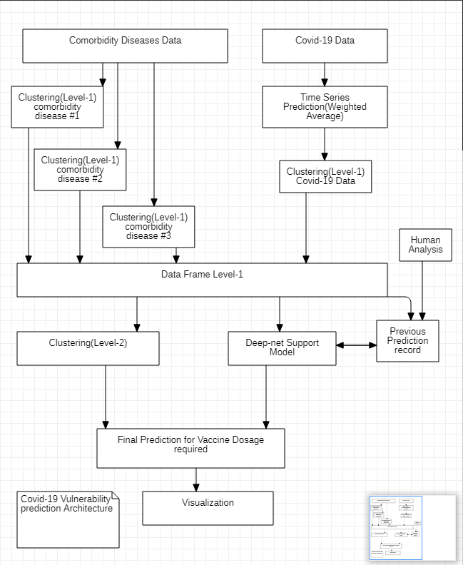

Daily Case Data for Covdi-19 is classified based on countries and processed by a Time Series Predictor (Weighted Average), Giving more weight to the latest data.

Data is then passed to Level-1 Clustering to detect patterns in the data by classifying it into clusters.

Clusters are classified into various severity levels based on sample analysis of clusters.

Finally, The other features like Diabetes, HIV, BP etc. are also fed into Layer-1 Clustering and categorised into the severity

based on sample analysis.

Finally, the severity data is generated disease wise for every country in Level-1 Clustering is passed into Level- 2 Clustering. At the same time, this data is fed into a Single layer Deep-net Model with 64 neurons followed by a Rectified linear activation function (Relu).

Level-2 Clustering generated clusters are also categorised into the severity level based on the severity data generated at level-1 Clustering.

Hence we can achieve a rough prediction on the trend of covid expected in future in different countries.

The Deep Net Model Predictor is trained on data predicted by Level-2 Clustering model along with human-verified predictions of Level-2 Clusters making the Deep net model increase the accuracy of prediction thus reducing the errors caused by the inaccuracies and missing values in original Data sets for Diseases and covid-19.

Auto Labeling:- To enable algorithms to classify clusters automatically, a couple of parameters are provided. One is the indication whether higher or lower the value is better(i.e number of HIV patients will indicate to the algorithm that higher the number of patients higher the severity of the cluster ) Hence for every column we enter a value of 1(Higher is better) or -1(lower is better) and an array is passed in the function. Function calculate a score for each cluster and sort them according to their severity.

Deciding on no of clusters or the ‘K’ for the K-mean algorithm was a challenging task as the results kept varying with the dataset. Hence it's hard to decide upon how many no of clusters were fitting the data effectively. Hence we tried to automate this as well. Here the Algorithm brute forces by calculating the Inter and intra cluster distance from all the points. Hence the algo tries to minimize the cohesion (Intra cluster length ) and reduce the coupling between clusters by maximizing the inter-cluster length. Hence try to find a perfect fit.

**OBSERVATIONS: (Interpretation)**

The above approach yields some good results at level-1 Clustering. Datasets like Covid-19, Diabetes provide good patterns. However, a larger sample size can perform better.

**Diagram-1**

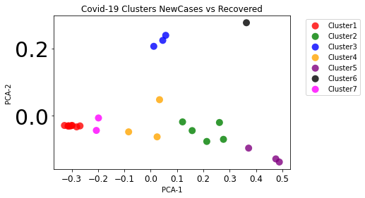

**Diagram-2**

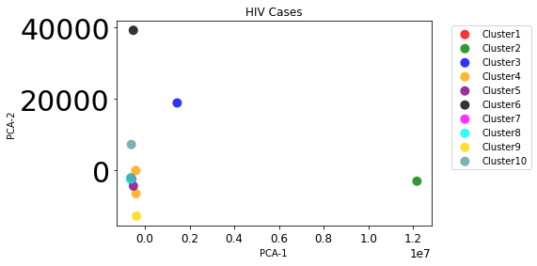

**Diagram-3**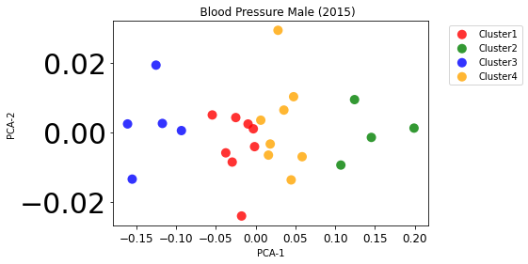

However, in Level-2 results, some bias was observed for the population size of the country. Otherwise, the results were accurate.

**Diagram-4**

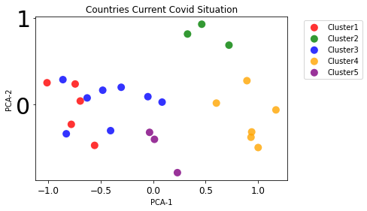

**Diagram-5**

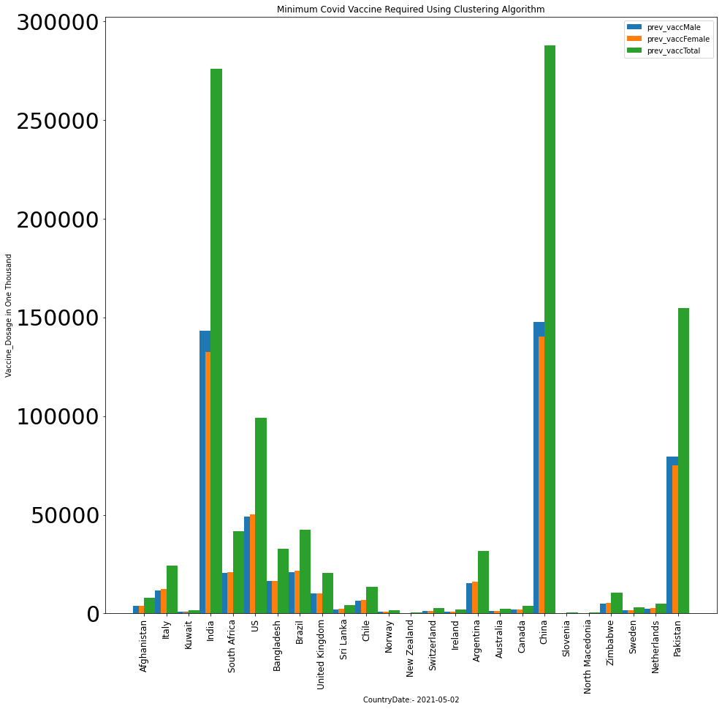

However, larger sample size can perform better for Level-2.

The deep Net model showed marginal improvement over the Level-2 Clustering results.

**Diagram-6**

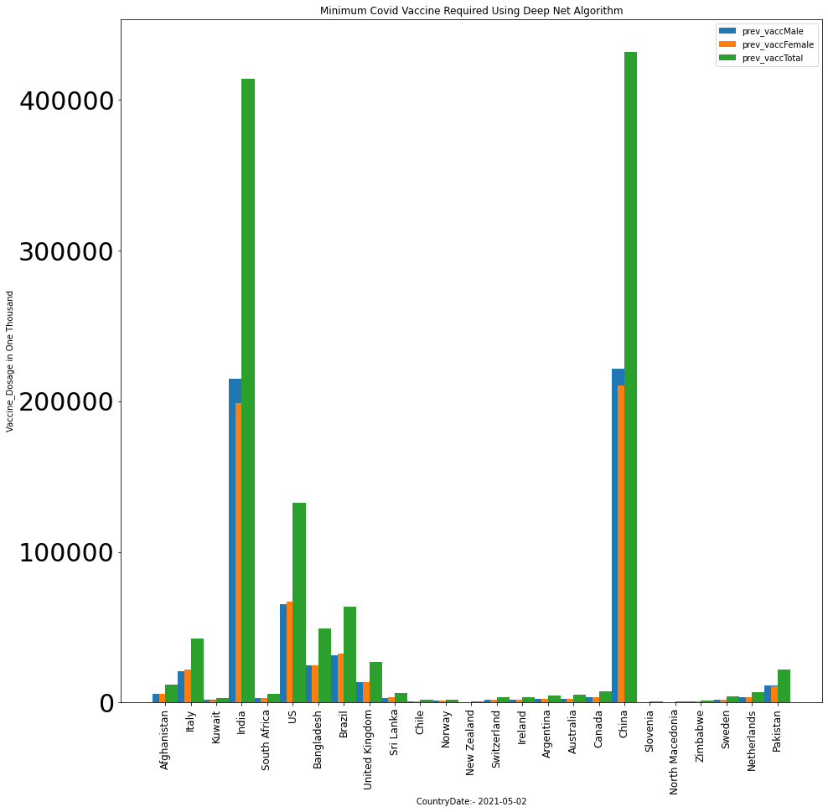

**CONCLUSION:**

Hence we can conclude that the above model can be very effective in tracking and controlling pandemic or epidemic level events. It provides guided decision making for resource deployment for maximum efficiency.

It can be effective both at the global, country or district level to tackle diseases provided access to accurate and relevant data.

**FUTURE WORK:**

The model has a great potential for providing efficient data assisted decision making for diseases. We plan to integrate this model in a dashboard with custom data input making it plug and play and easy to use

**ACKNOWLEDGMENT**

**REFERENCES (Sample)**

[1] S. M. Metev and V. P. Veiko, Laser Assisted Microtechnology, 2nd

ed., R. M. Osgood, Jr., Ed. Berlin, Germany: Springer-Verlag, 1998.

[2] J. Breckling, Ed., The Analysis of Directional Time Series:

---------------------------------------------------------------------------------------------------------------------

**Sample IEEE Paper for A4 Page Size**

**First Author #1 , Second Author *2 , Third Author #3**

**# First-Third Department, First-Third University**

**Address Including Country Name**

**1 first.author@first-third.edu**

**3 third.author@first-third.edu**

**\* Second Company**

**Address Including Country Name**

**2 second.author@second.com**

**Abstract—** This document gives formatting instructions for

authors preparing papers for publication in the Proceedings of

an IEEE conference. The authors must follow the instructions

given in the document for the papers to be published. You can

use this document as both an instruction set and as a template

into which you can type your own text.

Keywords— Include at least 5 keywords or phrases

**I. INTRODUCTION**

This document is a template. An electronic copy

can be downloaded from the conference website.

For questions on paper guidelines, please contact

the conference publications committee as indicated

on the conference website. Information about final

paper submission is available from the conference

website.

**II. PAGE LAYOUT**

An easy way to comply with the conference

paper formatting requirements is to use this

document as a template and simply type your text into it.

A. Page Layout

Your paper must use a page size corresponding to A4 which is 210mm (8.27&quot;) wide and 297mm

(11.69&quot;) long. The margins must be set as follows:

Top = 19mm (0.75&quot;)

Bottom = 43mm (1.69&quot;)

Left = Right = 14.32mm (0.56&quot;)

Your paper must be in two column format with a

space of 4.22mm (0.17&quot;) between columns.

**III. PAGE STYLE**

All paragraphs must be indented. All paragraphs

must be justified, i.e. both left-justified and right-

justified.

A. Text Font of Entire Document

The entire document should be in Times New

Roman or Times font. Type 3 fonts must not be

used. Other font types may be used if needed for

special purposes.

Recommended font sizes are shown in Table 1.

B. Title and Author Details

Title must be in 24 pt Regular font. Author name

must be in 11 pt Regular font. Author affiliation

must be in 10 pt Italic. Email address must be in 9

pt Courier Regular font.

TABLE I

FONT SIZES FOR PAPERS

FontSize Appearance (in Time New Roman or Times)Regular Bold Italic 8 table caption (in Small Caps),figure caption,reference item

reference item

(partial)

9 author email address

(in Courier),cell in a table

abstract

body

abstract heading

(also in Bold)

10 level-1 heading (in

Small Caps),

paragraph

level-2 heading,

level-3 heading,

author affiliation

11 author name

24 title

All title and author details must be in single-

column format and must be centered.

Every word in a title must be capitalized except

for short minor words such as “a”, “an”, “and”,

“as”, “at”, “by”, “for”, “from”, “if”, “in”, “into”,

“on”, “or”, “of”, “the”, “to”, “with”.

Author details must not show any professional

title (e.g. Managing Director), any academic title

(e.g. Dr.) or any membership of any professional

organization (e.g. Senior Member IEEE).

To avoid confusion, the family name must be

written as the last part of each author name (e.g.

John A.K. Smith).

Each affiliation must include, at the very least,

the name of the company and the name of the

country where the author is based (e.g. Causal

Productions Pty Ltd, Australia).

Email address is compulsory for the

corresponding author.

C. Section Headings

No more than 3 levels of headings should be

used. All headings must be in 10pt font. Every

word in a heading must be capitalized except for

short minor words as listed in Section III-B.

1) Level-1 Heading: A level-1 heading must be in Small

Caps, centered and numbered using uppercase Roman

numerals. For example, see heading “III. Page Style” of this

document. The two level-1 headings which must not be

numbered are “Acknowledgment” and “References”.

2) Level-2 Heading: A level-2 heading must be in Italic,

left-justified and numbered using an uppercase alphabetic

letter followed by a period. For example, see heading “C.

Section Headings” above.

3) Level-3 Heading: A level-3 heading must be indented,

in Italic and numbered with an Arabic numeral followed by a

right parenthesis. The level-3 heading must end with a colon.

The body of the level-3 section immediately follows the level-

3 heading in the same paragraph. For example, this paragraph

begins with a level-3 heading.

B. Figures and Tables

Figures and tables must be centered in the

column. Large figures and tables may span across

both columns. Any table or figure that takes up

more than 1 column width must be positioned either

at the top or at the bottom of the page.

Graphics may be full color. All colors will be

retained on the CDROM. Graphics must not use

stipple fill patterns because they may not be

reproduced properly. Please use only SOLID FILL

colors which contrast well both on screen and on a

black-and-white hardcopy, as shown in Fig. 1.

Fig. 1 A sample line graph using colors which contrast well both on screen

and on a black-and-white hardcopy

Fig. 2 shows an example of a low-resolution

image which would not be acceptable, whereas Fig.

3 shows an example of an image with adequate

resolution. Check that the resolution is adequate to

reveal the important detail in the figure.

Please check all figures in your paper both on

screen and on a black-and-white hardcopy. When

you check your paper on a black-and-white

hardcopy, please ensure that:

the colors used in each figure contrast well,

the image used in each figure is clear,

all text labels in each figure are legible.

A. Figure Captions

Figures must be numbered using Arabic

numerals. Figure captions must be in 8 pt Regular

font. Captions of a single line (e.g. Fig. 2) must be

centered whereas multi-line captions must be

justified (e.g. Fig. 1). Captions with figure numbers

must be placed after their associated figures, as

shown in Fig. 1.

Fig. 2 Example of an unacceptable low-resolution image

Fig. 3 Example of an image with acceptable resolution

B. Table Captions

Tables must be numbered using uppercase

Roman numerals. Table captions must be centred

and in 8 pt Regular font with Small Caps. Every

word in a table caption must be capitalized except

for short minor words as listed in Section III-B.

Captions with table numbers must be placed before

their associated tables, as shown in Table 1.

C. Page Numbers, Headers and Footers

Page numbers, headers and footers must not be

used.

D. Links and Bookmarks

All hypertext links and section bookmarks will be

removed from papers during the processing of

papers for publication. If you need to refer to an

Internet email address or URL in your paper, you

must type out the address or URL fully in Regular

font.

E.

References

The heading of the References section must not

be numbered. All reference items must be in 8 pt

font. Please use Regular and Italic styles to

distinguish different fields as shown in the

References section. Number the reference items

consecutively in square brackets (e.g. [1]).

When referring to a reference item, please simply

use the reference number, as in [2]. Do not use

“Ref. [3]” or “Reference [3]” except at the

beginning of a sentence, e.g. “Reference [3] shows

…”. Multiple references are each numbered with

separate brackets (e.g. [2], [3], [4]–[6]).

Examples of reference items of different

categories shown in the References section include:

example of a book in [1]

example of a book in a series in [2]

example of a journal article in [3]

example of a conference paper in [4]

example of a patent in [5]

example of a website in [6]

example of a web page in [7]

example of a databook as a manual in [8]

example of a datasheet in [9]

example of a master’s thesis in [10]

example of a technical report in [11]

example of a standard in [12]

**IV. CONCLUSIONS**

The version of this template is V2. Most of the

formatting instructions in this document have been

compiled by Causal Productions from the IEEE

LaTeX style files. Causal Productions offers both

A4 templates and US Letter templates for LaTeX

and Microsoft Word. The LaTeX templates depend

on the official IEEEtran.cls and IEEEtran.bst files,

whereas the Microsoft Word templates are self-

contained. Causal Productions has used its best

efforts to ensure that the templates have the same

appearance.

Causal Productions permits the distribution and

revision of these templates on the condition that

Causal Productions is credited in the revised

template as follows: “original version of this

template was provided by courtesy of Causal

Productions (www.causalproductions.com)”.

**ACKNOWLEDGMENT**

The heading of the Acknowledgment section and

the References section must not be numbered.

Causal Productions wishes to acknowledge

Michael Shell and other contributors for developing

and maintaining the IEEE LaTeX style files which

have been used in the preparation of this template.

To see the list of contributors, please refer to the top

of file IEEETran.cls in the IEEE LaTeX

distribution.

**REFERENCES**

[1] S. M. Metev and V. P. Veiko, Laser Assisted Microtechnology, 2nd

ed., R. M. Osgood, Jr., Ed. Berlin, Germany: Springer-Verlag, 1998.

[2] J. Breckling, Ed., The Analysis of Directional Time Series:

Applications to Wind Speed and Direction, ser. Lecture Notes in

Statistics. Berlin, Germany: Springer, 1989, vol. 61.

[3] S. Zhang, C. Zhu, J. K. O. Sin, and P. K. T. Mok, “A novel ultrathin

elevated channel low-temperature poly-Si TFT,” IEEE Electron Device

Lett., vol. 20, pp. 569–571, Nov. 1999.

[4] M. Wegmuller, J. P. von der Weid, P. Oberson, and N. Gisin, “High

resolution fiber distributed measurements with coherent OFDR,” in

Proc. ECOC’00, 2000, paper 11.3.4, p. 109.

[5] R. E. Sorace, V. S. Reinhardt, and S. A. Vaughn, “High-speed digital-

to-RF converter,” U.S. Patent 5 668 842, Sept. 16, 1997.

[6] (2002) The IEEE website. [Online]. Available: http://www.ieee.org/

[7] M. Shell. (2002) IEEEtran homepage on CTAN. [Online]. Available:

http://www.ctan.org/tex-

archive/macros/latex/contrib/supported/IEEEtran/

[8] FLEXChip Signal Processor (MC68175/D), Motorola, 1996.

[9] “PDCA12-70 data sheet,” Opto Speed SA, Mezzovico, Switzerland.

[10] A. Karnik, “Performance of TCP congestion control with rate

feedback: TCP/ABR and rate adaptive TCP/IP,” M. Eng. thesis, Indian

Institute of Science, Bangalore, India, Jan. 1999.

[11] J. Padhye, V. Firoiu, and D. Towsley, “A stochastic model of TCP

Reno congestion avoidance and control,” Univ. of Massachusetts,

Amherst, MA, CMPSCI Tech. Rep. 99-02, 1999.

[12] Wireless LAN Medium Access Control (MAC) and Physical Layer

(PHY) Specification, IEEE Std. 802.11, 1997.

Sample Headings

Abstract

Introduction

Data Exploration - issues|cleaning need

Methodology | discussion/observations

Results

Conclusion

Future prospects - Complete automatic & data -driven

Reference

**Sample format for a health cluster bulletin**

|  |  |
| --- | --- |
|  |  |
|  |  |

**Bulletin # 1**

Date

**Highlights**

* · *Example of text*
* · *Major points of interest*
* · *…*
* · *…*
* · *…*
* · *…*
* · *…*
* · *…*
* · *…*
* · *…*
* · *…*
* · *…*

·

# **Assessment**

* + · Quote here **major outcomes** of health related assessments performed during the week quoting date, location, major outcomes and agency that performed the assessment.
  + ( actual real-time correlation by taking last 10 days data & relation / comparison of predicted )
  + Encourage agencies in using same assessment formats.
  + · Quote here epidemiological abstracts from the surveillance system
  + · Quote here summary of priority needs/gaps

# **Coordination**

* Quote here coordination meetings quoting: dates, venue and **major outcomes**
* ·

# **Filling Gaps**

* Quote here activities conducted by various agencies to fill existing gaps such as: immunization; drug and medical supplies; rehabilitation of health infrastructures; mobile medical teams, field hospitals, Water and sanitation, Mental health, etc. Each activity should be described in one bullet point and should include information on location, date and name of implementing agency.

· …how we can help- giving data driven decisions/hints in respect ...vaccination, immunization , can be charted out & expanded for other applications

# **Capacity Building**

* · Quote here actions implemented to strengthen the local capacity in dealing with health emergencies such as: training (quote number of trainees and duration); specific support provided to MoH Crisis Cells, development and dissemination of guidelines; etc.

· … govt can pre plan the order the quantities/….predict situations and taking stocking, ordering decisions accordingly

· …

# **Summary of Resources Available**

* · Insert here an update table on funds requested and received by the various health agencies ( source: OCHA Financial Tracking System)

|  |  |  |  |
| --- | --- | --- | --- |
| Agency | Funds Requested | Funds Received (US$) | Shortcoming  % |
|  |  |  |  |
|  |  |  |  |
|  |  |  |  |

# **Contacts**

· Insert here a table as follows:

|  |  |  |  |
| --- | --- | --- | --- |
| Agency | Field of activity  (mobile teams; drug supply, reconstruction, training, etc.) | Location | Contacts |
|  |  |  |  |
|  |  |  |  |
|  |  |  |  |

|  |  |
| --- | --- |
|  |  |
|  |  |